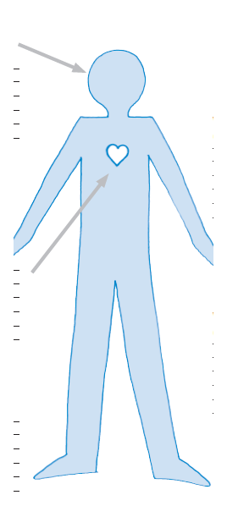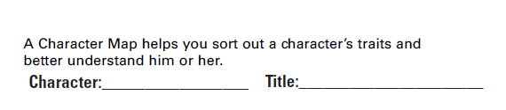0

**SPEAKER**

Just as a short story has a narrator, a poem has a speaker. The **speaker** is the voice that “talks” to the reader. The speaker may be the poet or a fictional character. (Be aware that even when a poem uses the pronouns “I” or “me”, it does not always mean that the poet is the speaker). Identifying the speaker, and understanding his or her situation, is an essential part of discovering the meaning of the poem.

What the speaker did:

What the speaker thought:

How the speaker felt:

*What can be inferred based on line 7 in the poem? Why is line 7 the only line with one word and what was the author’s purpose in formatting the poem this way?

What is the subject of the poem?

What is the poet’s tone (attitude towards the subject?)

How others reacted towards the speaker: *You might have to make an inference.*

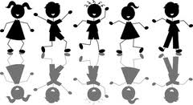

Infer what might have motivated the speaker to talk with her son?

**Mother to Son**  
*by Langston Hughes*

|  |
| --- |
| Well, son, I'll tell you: Life for me ain't been no crystal stair. It's had tacks in it, And splinters, And boards torn up, And places with no carpet on the floor— Bare. But all the time I'se been a-climbin' on, And reachin' landin's, And turnin' corners, And sometimes goin' in the dark Where there ain't been no light. So, boy, don't you turn back. Don't you set down on the steps. 'Cause you finds it's kinder hard.  Don't you fall now— For I'se still goin', honey,  I'se still climbin', And life for me ain't been no crystal stair. |

Who is the speaker?

Who is the speaker’s intended audience?

Speaker compares ___________________________ to ________________________________ using an extended metaphor.

What can the reader infer?

What does the speaker describe?



What can the reader infer?

What can be inferred based on the dialect?

What does the speaker continue to do?

What does the speaker say to do?

What are some examples of dialect in the poem?

What can the reader infer?

What has the speaker done?

What is the topic of the poem?

Write a theme statement for the poem.

What does the speaker want?

Name _____________________________ Date ____

**Quiz**

**“Mother to Son”** by Langston Hughes Directions: Reread the poem, “Mother to Son” and answer the following comprehension questions.

1. To what are splinters and tacks compared to in the poem?

A memories

B tools

C hardships

D childhood

2. Which type of person is most like the mother?

A someone who gives up at the first sign of trouble

B someone who doesn’t have advice for others

C someone who has a carefree, luxurious life

D someone who works hard despite setbacks

3. In line 2, the speaker says “Life for my ain’t been no crystal stair.” What does the speaker mean by *crystal stair*?

A bare and colorful

B breakable and hard

C rich and easy

D steep and dangerous

8. Discuss how this poem relates to the theme, “Life is not Fair,” specifically the essential question, “How can we make life worthwhile even though it seems unfair?” Use the experiences and words of the speaker as evidence to support your answer.

4. What is the most likely reason why the author uses words like “ain’t” and “I’se” ?

A to prove that the speaker has a crystal stair

B to encourage people to follow their dreams

C to make it sound like a real person’s conversation

D to show that the reader should trust the speaker

5. The speaker in “Mother to Son” would most likely describe herself as

A. timid

B. fortunate

C. determined

D. short-tempered

6. When the speaker talks about turning corners, she is most likely referring to

A. trying to escape from danger

B. feeling lost and confused

C. experiences disappointment

D. coping with changes in her life

7. Based on the speaker’s statements in “Mother to Son,” what can you infer about the reason for her talk with him?

A. The son wants to give up on something

B. They are resolving an argument

C. The mother needs to complain about her life

D. They are reuniting after a long separation.

Source: The Poems of Emily Dickinson Edited by R. W. Franklin (Harvard University Press, 1999)

***Mother to Son***

by Langston Hughes

Extended Metaphor Writing Activity

**Part I: Pre-Write**

1. Read “Mother to Son,” by Langston Hughes, the famous Harlem Renaissance poet.

2. Write your own version of “Mother to Son.” (see student examples)

3. You will create your own “extended metaphor” and will emulate the format of the great poem.

Hughes’ poem has twenty lines; yours will have twenty lines.

4. Yes, it’s true! You need to use the same punctuation marks and in the same places as the original poet, Langston Hughes. So, don’t forget to copy them into your final publication.

5. And yes, again…since you’re emulating the poet, you should mimic his version by using the same format.

6. Use the brainstorming activities below. Then, draft your own extended metaphor poem on the next page.

**Part II: Brainstorm**

1. The poet’s example of metaphor compares “life” to a “crystal stair.”

2. Brainstorm your own list of metaphors for life below.

* ______________________________________________________
* ______________________________________________________
* ______________________________________________________
* ______________________________________________________
* ______________________________________________________

***Life is…***

3. Choose your favorite metaphor for life above. Highlight or circle it in the box.

4. Read the poet’s metaphor again. “Life ain’t been no crystal stair.”

Ask yourself: what is the opposite of “crystal stair” as it is used in the poem?

* tacks
* splinters
* boards torn up
* no carpet on the floor
* bare
* no light

5. Opposite of __________________________ (my metaphor). List below…

* _____________________________
* _____________________________
* _____________________________
* _____________________________
* _____________________________

**“Mother to Son” Writing Activity**

Directions: Follow this template/format, including line length and punctuation, but create your very own *extended metaphor.*

**Well**, ____________________________________________________, **I’ll tell you:**

**Life** ________________________________________________________________________.

**It’s** ____________________________________________________.

**And** _________________________________.

**And** _________________________________.

**And** _________________________________________________________ --

___________________.

**But** _________________________________________________

**(I’se/I’ve)** _________________________________________________________,

**And** _____________________________________________________________ ,

**And** _____________________________________________________________,

**And sometimes** ___________________________________________

**Where** _____________________________________________________.

**So** ___________________, **don’t you** ___________________________________.

**Don’t you** _______________________________________________________________.

**(Cause/Because) you** _________________________________________________________.

**Don’t you** ___________________________________ --

**For (I’se/I’m) still** _____________________________________________.

**(I’se/I’m) still** ____________________________________________,

**And life for me** ______________________________________________________________.